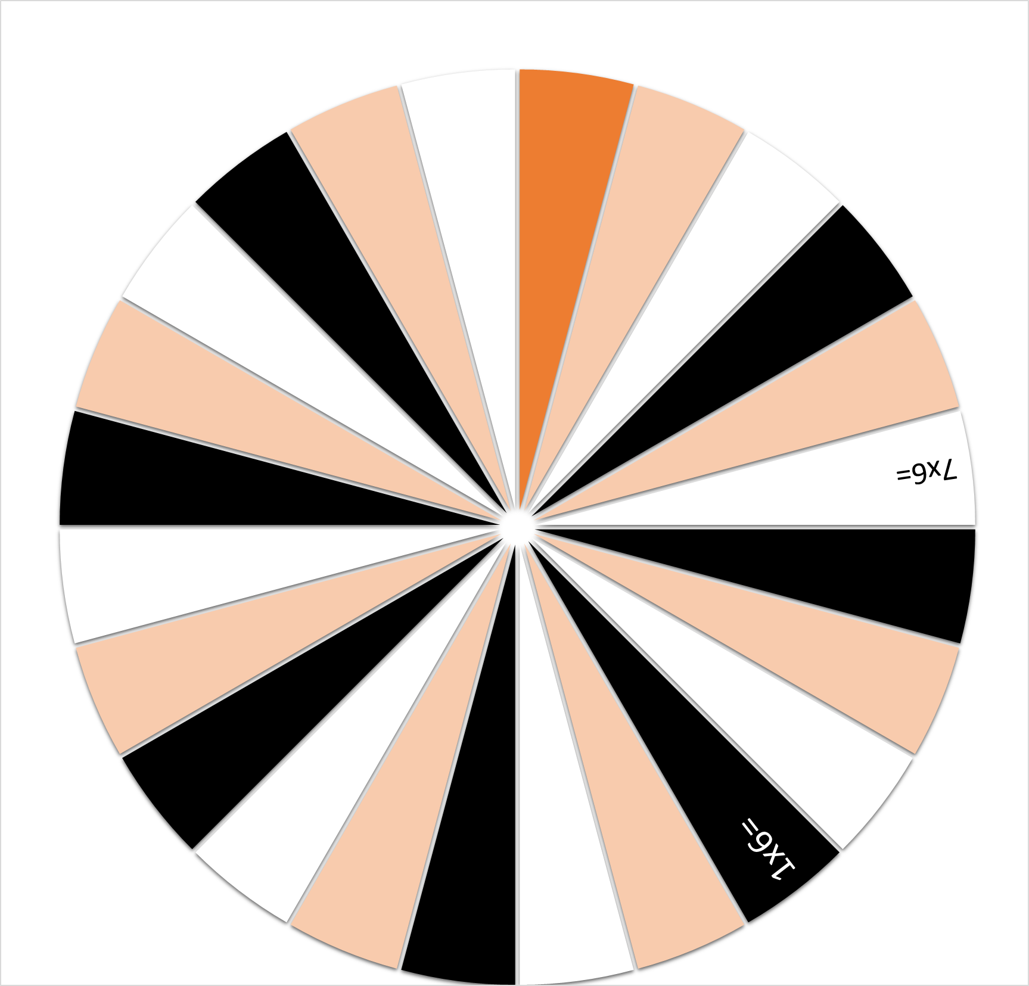

1x6=

4x6=

4x6=

4x6=

6x6=

5x6=

10x6=

8x6=

2x6=

1x6=

2x6=

3x6=

9x6=

2x6=

3x6=

8x6=

10x6=

6x6=

5x6=

7x6=

9x6=

3x6=